UNITED STATES
SECURITIES AND EXCHANGE COMMISSION
Washington, D.C. 20549
_____________________________________________________________________________
FORM 8-K
_____________________________________________________________________________
CURRENT REPORT
Pursuant to Section 13 or 15(d) of the Securities Exchange Act of 1934

Date of Report (Date of earliest event reported): May 15, 2023
______________________________________________________________________________
Tradeweb Markets Inc.
(Exact name of registrant as specified in charter)
______________________________________________________________________________

Delaware |  |  | 001-38860 |  |  | 83-2456358
(State or Other Jurisdiction  of Incorporation) |  |  | (Commission  File Number) |  |  | (I.R.S. Employer  Identification No.)
1177 Avenue of the Americas  New York, New York |  |  |  |  |  | 10036
(Address of Principal Executive Offices) |  |  |  |  |  | (Zip Code)
Registrant’s telephone number, including area code: (646) 430-6000
______________________________________________________________________________

Check the appropriate box below if the Form 8-K filing is intended to simultaneously satisfy the filing obligation of the registrant under any of the following provisions:
☐ |  |  | Written communications pursuant to Rule 425 under the Securities Act (17 CFR 230.425)
☐ |  |  | Soliciting material pursuant to Rule 14a-12 under the Exchange Act (17 CFR 240.14a-12)
☐ |  |  | Pre-commencement communications pursuant to Rule 14d-2(b) under the Exchange Act (17 CFR 240.14d-2(b))
☐ |  |  | Pre-commencement communications pursuant to Rule 13e-4(c) under the Exchange Act (17 CFR 240.13e-4(c))
Securities registered pursuant to Section 12(b) of the Act:
Title of each class |  |  |  |  |  | Trading Symbol(s) |  |  |  |  |  | Name of each exchange on which  registered
Class A common stock, par value $0.00001 |  |  |  |  |  | TW |  |  |  |  |  | Nasdaq Global Select Market

Indicate by check mark whether the registrant is an emerging growth company as defined in Rule 405 of the Securities Act of 1933 (§230.405 of this chapter) or Rule 12b-2 of the Securities Exchange Act of 1934 (§240.12b-2 of this chapter).

Emerging growth company ☐

If an emerging growth company, indicate by check mark if the registrant has elected not to use the extended transition period for complying with any new or revised financial accounting standards provided pursuant to Section 13(a) of the Exchange Act. ☐

Item 5.02. Departure of Directors or Certain Officers; Election of Directors; Appointment of Certain Officers; Compensatory Arrangements of Certain Officers.

On May 9, 2023, Lee Olesky informed the Board of Directors (the "Board") of Tradeweb Markets Inc. (the "Company") that he will resign from his position as Chairperson of the Board and as a member of the Board, effective as of June 30, 2023. Mr. Olesky's resignation is not due to any disagreement with the Company. On May 12, 2023, the Board elected Jacques Aigrain to succeed Mr. Olesky as Chairperson of the Board, effective as of July 1, 2023. On May 9, 2023, the Compensation Committee of the Board approved pro-rata vesting of Mr. Olesky's previously awarded non-employee director restricted stock unit grant to reflect time served in the role.

Item 7.01. Regulation FD Disclosure.

On May 15, 2023, the Company issued a press release, a copy of which is furnished as Exhibit 99.1 hereto, regarding the foregoing board leadership changes.

In accordance with General Instruction B.2 of Form 8-K, the information presented herein under Item 7.01 and set forth in Exhibit 99.1 attached hereto, shall not be deemed “filed” for the purposes of Section 18 of the Securities Exchange Act of 1934, as amended (the “Exchange Act”), or otherwise subject to the liabilities of that section, nor shall it be deemed incorporated by reference in any filing under the Securities Act of 1933, as amended, or the Exchange Act, except as shall be expressly set forth by specific reference in such a filing.

Item 9.01. Financial Statements and Exhibits.

(d) Exhibits:
Exhibit  Number |  |  |  |  |  | Exhibit Description
99.1 |  |  |  |  |  | Press Release of Tradeweb Markets Inc., dated May 15, 2023.
104 |  |  |  |  |  | Cover Page Interactive Data File (embedded within the Inline XBRL document).

SIGNATURES

Pursuant to the requirements of the Securities Exchange Act of 1934, the registrant has duly caused this report to be signed on its behalf by the undersigned hereunto duly authorized.

 |  |  |  |  |  | TRADEWEB MARKETS INC.
Date: May 15, 2023 |  |  |  |  |  | By: |  |  | /s/ Douglas Friedman
 |  |  |  |  |  |  |  |  | Name: Douglas Friedman
 |  |  |  |  |  |  |  |  | Title: General Counsel

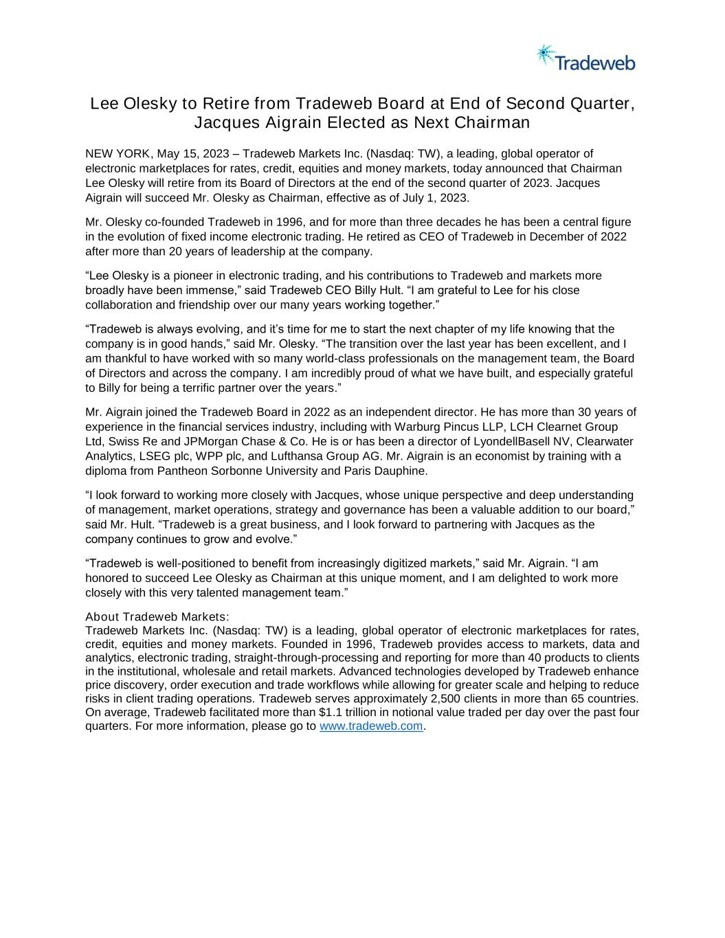

Lee Olesky to Retire from Tradeweb Board at End of Second Quarter, Jacques Aigrain Elected as Next Chairman NEW YORK, May 15, 2023 – Tradeweb Markets Inc. (Nasdaq: TW), a leading, global operator of electronic marketplaces for rates, credit, equities and money markets, today announced that Chairman Lee Olesky will retire from its Board of Directors at the end of the second quarter of 2023. Jacques Aigrain will succeed Mr. Olesky as Chairman, effective as of July 1, 2023. Mr. Olesky co-founded Tradeweb in 1996, and for more than three decades he has been a central figure in the evolution of fixed income electronic trading. He retired as CEO of Tradeweb in December of 2022 after more than 20 years of leadership at the company. “Lee Olesky is a pioneer in electronic trading, and his contributions to Tradeweb and markets more broadly have been immense,” said Tradeweb CEO Billy Hult. “I am grateful to Lee for his close collaboration and friendship over our many years working together.” “Tradeweb is always evolving, and it’s time for me to start the next chapter of my life knowing that the company is in good hands,” said Mr. Olesky. “The transition over the last year has been excellent, and I am thankful to have worked with so many world-class professionals on the management team, the Board of Directors and across the company. I am incredibly proud of what we have built, and especially grateful to Billy for being a terrific partner over the years.” Mr. Aigrain joined the Tradeweb Board in 2022 as an independent director. He has more than 30 years of experience in the financial services industry, including with Warburg Pincus LLP, LCH Clearnet Group Ltd, Swiss Re and JPMorgan Chase & Co. He is or has been a director of LyondellBasell NV, Clearwater Analytics, LSEG plc, WPP plc, and Lufthansa Group AG. Mr. Aigrain is an economist by training with a diploma from Pantheon Sorbonne University and Paris Dauphine. “I look forward to working more closely with Jacques, whose unique perspective and deep understanding of management, market operations, strategy and governance has been a valuable addition to our board,” said Mr. Hult. “Tradeweb is a great business, and I look forward to partnering with Jacques as the company continues to grow and evolve.” “Tradeweb is well-positioned to benefit from increasingly digitized markets,” said Mr. Aigrain. “I am honored to succeed Lee Olesky as Chairman at this unique moment, and I am delighted to work more closely with this very talented management team.” About Tradeweb Markets: Tradeweb Markets Inc. (Nasdaq: TW) is a leading, global operator of electronic marketplaces for rates, credit, equities and money markets. Founded in 1996, Tradeweb provides access to markets, data and analytics, electronic trading, straight-through-processing and reporting for more than 40 products to clients in the institutional, wholesale and retail markets. Advanced technologies developed by Tradeweb enhance price discovery, order execution and trade workflows while allowing for greater scale and helping to reduce risks in client trading operations. Tradeweb serves approximately 2,500 clients in more than 65 countries. On average, Tradeweb facilitated more than $1.1 trillion in notional value traded per day over the past four quarters. For more information, please go to www.tradeweb.com.

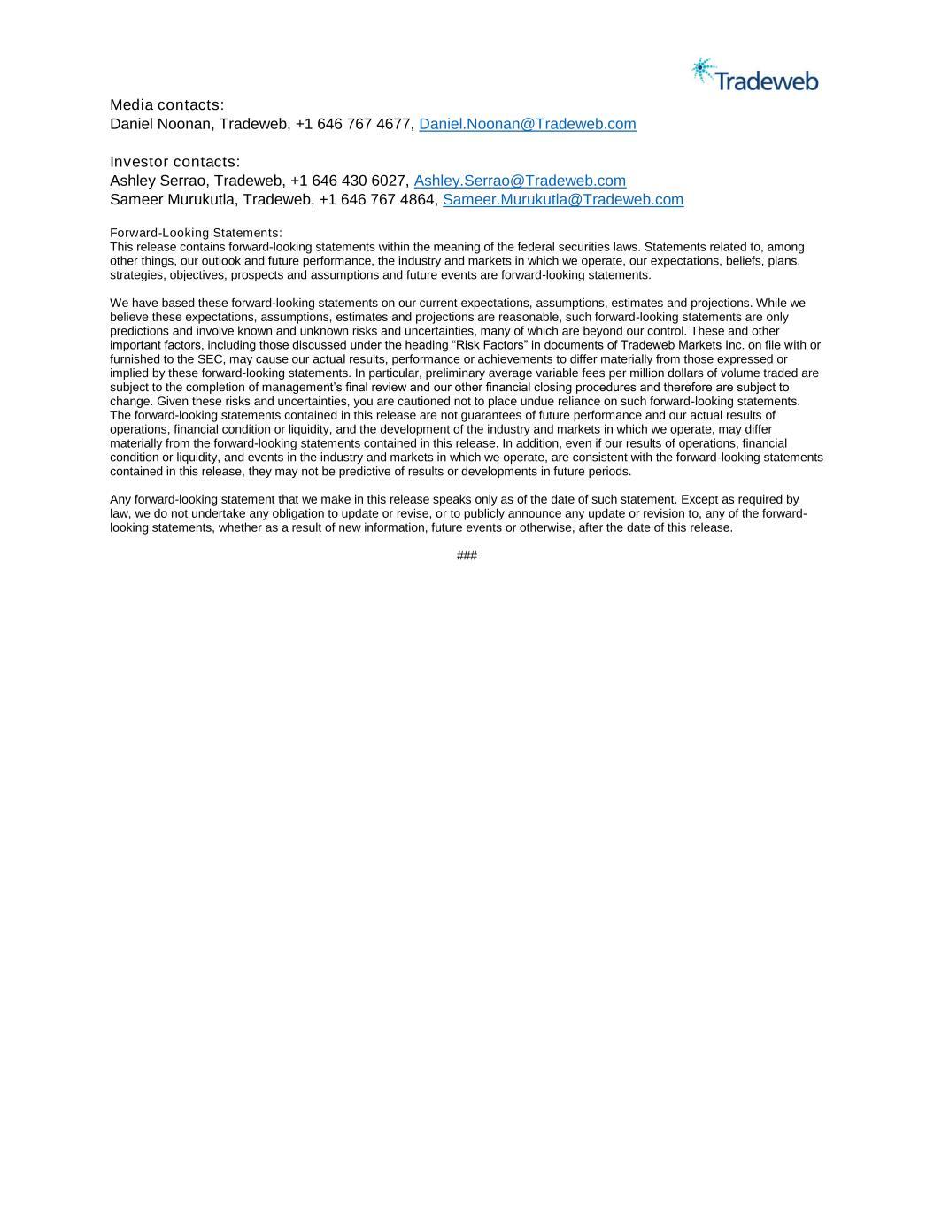
Media contacts: Daniel Noonan, Tradeweb, +1 646 767 4677, Daniel.Noonan@Tradeweb.com Investor contacts: Ashley Serrao, Tradeweb, +1 646 430 6027, Ashley.Serrao@Tradeweb.com Sameer Murukutla, Tradeweb, +1 646 767 4864, Sameer.Murukutla@Tradeweb.com Forward-Looking Statements: This release contains forward-looking statements within the meaning of the federal securities laws. Statements related to, among other things, our outlook and future performance, the industry and markets in which we operate, our expectations, beliefs, plans, strategies, objectives, prospects and assumptions and future events are forward-looking statements. We have based these forward-looking statements on our current expectations, assumptions, estimates and projections. While we believe these expectations, assumptions, estimates and projections are reasonable, such forward-looking statements are only predictions and involve known and unknown risks and uncertainties, many of which are beyond our control. These and other important factors, including those discussed under the heading “Risk Factors” in documents of Tradeweb Markets Inc. on file with or furnished to the SEC, may cause our actual results, performance or achievements to differ materially from those expressed or implied by these forward-looking statements. In particular, preliminary average variable fees per million dollars of volume traded are subject to the completion of management’s final review and our other financial closing procedures and therefore are subject to change. Given these risks and uncertainties, you are cautioned not to place undue reliance on such forward-looking statements. The forward-looking statements contained in this release are not guarantees of future performance and our actual results of operations, financial condition or liquidity, and the development of the industry and markets in which we operate, may differ materially from the forward-looking statements contained in this release. In addition, even if our results of operations, financial condition or liquidity, and events in the industry and markets in which we operate, are consistent with the forward-looking statements contained in this release, they may not be predictive of results or developments in future periods. Any forward-looking statement that we make in this release speaks only as of the date of such statement. Except as required by law, we do not undertake any obligation to update or revise, or to publicly announce any update or revision to, any of the forward- looking statements, whether as a result of new information, future events or otherwise, after the date of this release. ###

